190905104
Parth Shukla
Lab 2

Exercise questions

1)
Area of rectangle

l = int(input('Enter length l: '))
w = int(input('Enter width w: '))

print("Area is " + str(l*w*0.5))

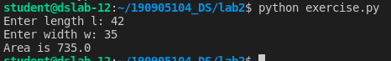

2)
x = int(input('Enter x: '))
y = int(input('Enter y: '))
temp =x
x = y
y = temp

print("x is " + str(x))
print("y is " + str(y))
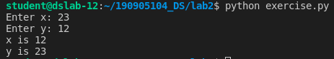

3)
x = int(input('Enter x: '))

if x % 2 == 0:
print("x is " + str("even"))
else:
print("x is " + str("odd"))

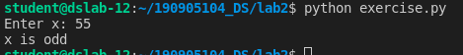

4)

x = int(input('Enter x: '))
y = int(input('Enter y: '))
z = int(input('Enter z: '))

if x >= y and x >= z :
print("x is " + str("largest"))

elif y >= x and y >= z :
print("y is " + str("largest"))

elif z >= x and z >= y :
print("z is " + str("largest"))

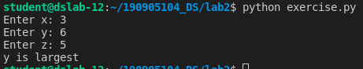

5)
y = int(input('Enter a number: '))

while(y > 0):
if y%5 ==0:
print( str(y) + " divisible by 5" )
else:
print( str(y) + " is not divisible by 5" )
y= y-1

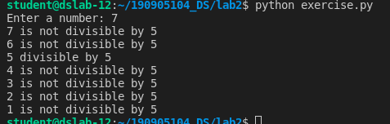

6)

a = ["A", "B"]
print(a)
a.append("C")
print(a)
a.extend(["D", "E"])
print(a)
a.insert(0, "F")
print(a)
a.insert(2, "G")
print(a)
a.remove("A")
print(a)

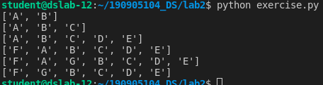

7)

t = (1,2,3,4,5,6,7,8,9,10)

for i in range(int(len(t)/2)):
print(t[i],end = " ")
print("\n")

for i in range(int(len(t)/2),int(len(t))):
print(t[i],end = " ")

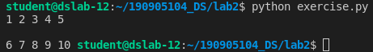

8)
t = (12,7,38,56,78)
t2 = []
for i in range(int(len(t))):
if t[i]%2 == 0:
t2.append(t[i])
tuple_t2 = tuple(t2)
print(tuple_t2)
print(type(tuple_t2))

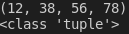

9)

l = [11,-21,0,45,66,-93]

[print(i) for i in l if i < 0]

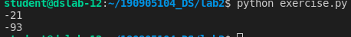

10)

l = [11,-21,0,45,66,-93]

i = len(l) - 1
while( i > 0):
if l[i] < 0:
print(l[i])
i = i-1

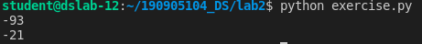

11)

l = [11,-21,0,45,66,-93]

pos = 0
neg = 0

for i in l:
if i > 0 :
pos = pos +1
elif i < 0 :
neg = neg + 1

print(l)
print("positive numbers " + str(pos) )
print("negative numbers " + str(neg) )

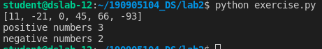

12)
l = [11,-21,0,45,66,-93]

[l.remove(i) for i in l if i%2 == 0]

[print(i,end = " ") for i in l ]

13)
import pandas as pd

dic = {'name': ['Parth', 'Matt', 'Dan'], 'height': ['2', '1', '3'], 'qualification': ['cool', 'very cool', 'not cool']}
df = pd.DataFrame.from_dict(dic)
print(df)

addr = ['Manipal', 'Mumbai', 'Delhi']

df['address'] = addr
print(df)

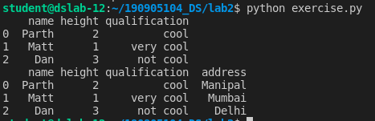

14)
import pandas as pd

dic = {'name': ['Parth', 'Matt', 'Dan'], 'height': ['2', '1', '3'], 'qualification': ['cool', 'very cool', 'not cool']}
df = pd.DataFrame.from_dict(dic)
print(df)

df.insert(3, "lastcol", ['data1', 'data2', 'data3'])
print(df)

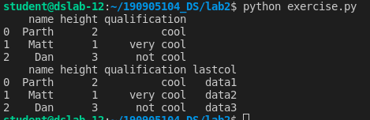

Intro to pandas

1)

import pandas as pd
import numpy as np

s = pd.Series([3, -2, 6, 8, 5])

print(s.min())
print(s.max())
print(s.sum())

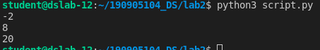

2)

import pandas as pd
data = [['Parth',20],['Matt',22],['Dan',23]]
df = pd.DataFrame(data,columns=['Name','Age'])

print(df)

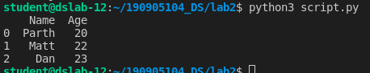

3)
import pandas as pd

data = {'Name':['Parth', 'Sudha', 'Raju'],'Age':[20,34,29]}
df = pd.DataFrame(data, index=['rank1','rank2','rank3'])
print(df)

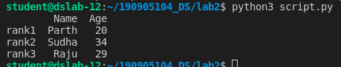

4)
df1=pd.DataFrame({'A':pd.Timestamp('20130102'),'B':np.array([3]*4,dtype='int32'),
'C':pd.Categorical(['Male','Female','Male','Female'])})

print(df1)
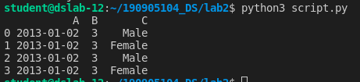

5)

df1=pd.DataFrame({'A':pd.Timestamp('20130102'),'B':np.array([3]*4,dtype='int32'),
'C':pd.Categorical(['Male','Female','Male','Female'])})
print('First 2 rows')
print(df1.head(2))

print('Last 2 rows')
print(df1.tail(2))

print(df1.describe())

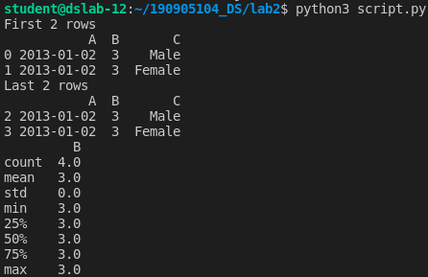

6)

dates=pd.date_range('20130101', periods=100)
df = pd.DataFrame(np.random.randn(100,4), index=dates, columns=list('ABCD'))

print(df.head())

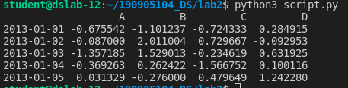

print(df.index)

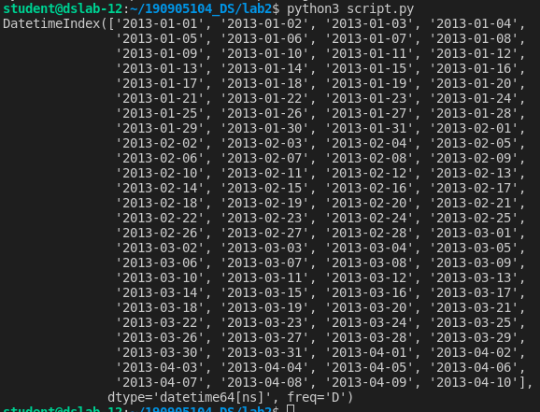

print(df.columns)

print(df.T)

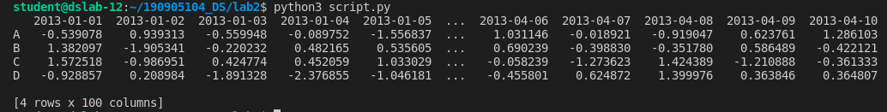
print(df.sort_index(axis=1, ascending=False) )

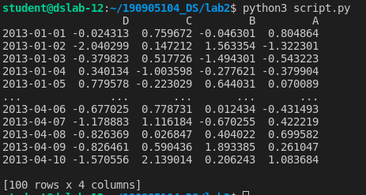

print(df.sort_values(by='B'))
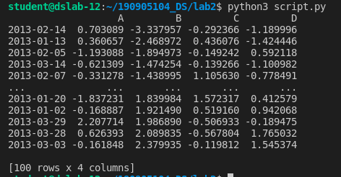

print(df[0:3])
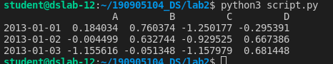

print(df['20130105':'20130110'] )

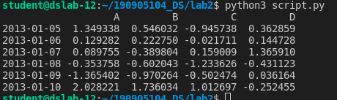

print(df.iloc[0])

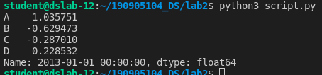

print( df.iloc[0,:2])

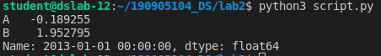

print(df[['A','B']][:5])

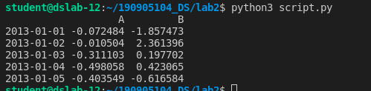
7) Boolean indexing

print(df[df.A>0])
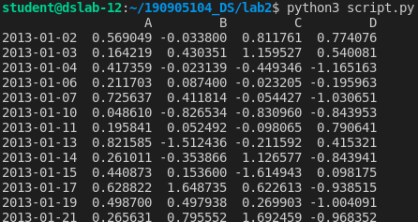

genders = ['M', 'F', 'NB']
df['F'] = np.random.choice(genders, len(df))

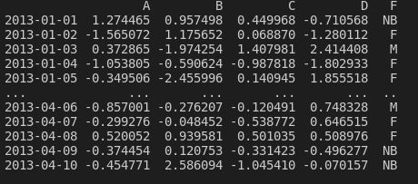

8) Drop

df.drop('B', inplace=True, axis = 1)
df.drop('20130102', axis = 0, inplace=True, )

9) Concatenate dataframes

dates=pd.date_range('20220101', periods=10)
df2 = pd.DataFrame(np.random.randn(10,3), index=dates, columns=list('XYZ'))

dates=pd.date_range('20130101', periods=10)
df1 = pd.DataFrame(np.random.randn(10,5), index=dates, columns=list('ABCDE'))

df_new = pd.concat([df1, df2])
print(df_new)

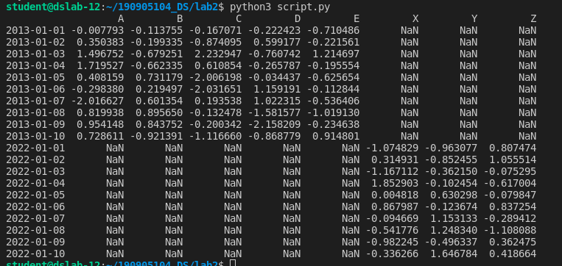

Matplotlib

import matplotlib.pyplot as plt
import pandas as pd

df = pd.read_csv('prima_indians_diabetes_for_Week2.csv', header=None)

df.columns=['preg','glu','bp','sft','ins','bmi','dpf','age','class']

plt.scatter(df['bmi'],df['glu'])
plt.xlabel('bmi')
plt.ylabel('Glucose')

plt.show()

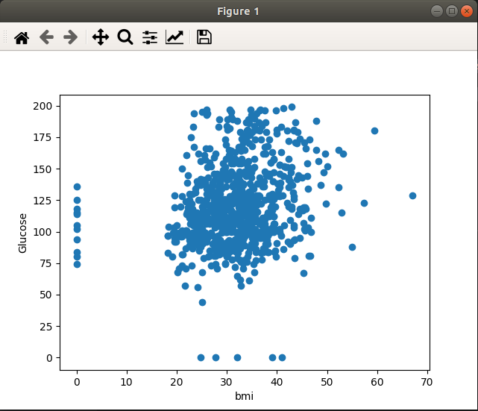

df['age'].hist()
plt.show()

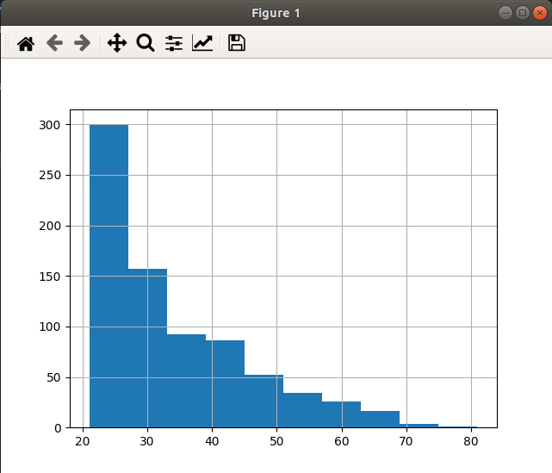

plt.boxplot([df.loc[df['class']==0]['age'], df.loc[df['class']==1]['age']])
plt.show()

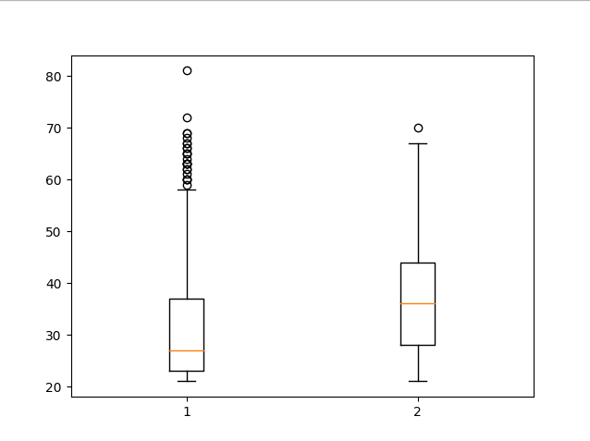

G=pd.read_excel('German Credit_for_Week2.xlsx',sheet_name='Sheet1',engine='openpyxl')
print(G.head())

